Currently, the only feasible technology for mirrors of the 30 meters class is segmentation. The stiffness is supplied by a control system using actuators for the rigid-body movements of the segments and edge sensors measuring, at high rate, the relative heighs of adjacent segments. The edge sensors need to be caliberated by optical sensors measuring the relative heights, from now on called piston steps, between neighbouring segments.
On the one hand, the sensor must be capable of measuring large piston steps of several micrometers after installations of segments. On the other hand, preferably also during operations to continually check the performance of the edge sensors, the sensor should be capable of measuring small piston steps of a few nanometers.as well as, preferably also during operations, small piston steps.
This paper compares two sensors that use spatial filtering in the focal plane to convert the phase steps into intensity variations. One of them is a simple circular pinhole and the other one a circular phase mask, that is a phase contrast sensor [?].
The theoretical comparison is based on a single phase step in the middle of a circular aperture. This implies that the neighbouring segments are not tilted with respect to each other.
To obtain a localized signal in the exit pupil, the diameters of the pinhole or the phase mask in the focal plane must be much larger than the diameter of the Airy disk. In the presence of atmospheric effects, the diameters must be of the order of the seeing disk.
The expected effect is the pinhole smears out the image of each segment. The overlapping smeared part will interfere with each other’s. On this overlapping zone there will be constructive interferences when the phase step between the two segment is zero or an integer multiple of the wavelength. And a destructive interference when the phase step is a multiple of half the wavelength. (Is this true ?)
For large piston steps a relatively coarse phasing can be done by modulating the piston step within a large range and detecting the maximum of the coherence envelope of the signal. For small piston steps, one can do single measurements with a narrow bandwidth, if sufficient light is available, or a broad bandwidth, if only dim stars are available.
Tests with the phase contrast sensor have been done in the laboratory and on sky with the APE experiment [?]. The spatial filter in the Zernike phase contrast Unit Sensor (ZEUS) was a parallel plate with a circular dip in the middle. The center of the dip was aligned in the focal plan with optical axis of the telescope. This depth of dip was equivalent to a phase shift of a quarter of the central wavelength of the chosen bandwidth. The piston steps were extracted from the signal by a fit of a theoretically expected shape.
The comparison between the two sensors in Section 2 will be done without and with atmospheric effects. Section 2 shows a few experimental results and Section3 will discuss the optimal choice of the sampling for a possible use of this type of sensor in the EELT.
The comparison will be based on the content of information in the signals analysed by specific algorithms. The chosen type of information is the Fisher information because of its close relationship to the achievable precision of the measurement expressed as the rms of the measuremet error.

The fisher information and the Cramer Rao Lower bound
This application of the Fisher information tto phase measurements has been discussed by Noethe et al(2007) and used by Surdej et al (2011). This section only summarizes the essential features of the use of Fisher information.
The Fisher information can be defined by
,
where being the probability that a photon will be detected at the location on the detector in the exit pupil, if the relative piston step is . Furthermore, the integral of over the pupil is equal to 1, expressing that the definition is valid for a single photon. The Fisher information is related to the lower bound (Cramer-Rao bound) with which the parameter can be estimated from the signal . For $N_{\textrm{photon}}$ the Cramer-Rao bound (CRB) is given by
(1)
For the measurement of a piston step the fundamental limit is given by [?]
(2)
All calculations will be done for one photon and the normalized Fisher information and the Cramer-Rao bound will be defined by
\begin{eqnarray}
\tilde {I}_{\mathrm{F}} = {I}_{\mathrm{F}} \frac{\lambda}{2\pi}\\
\tilde{\sigma}_{matrm CRB} & = & \sigma_{matrm CRB}\frac{2\pi}{\lambda}
\end{eqnarray}
The fundamental limit for both $ \tilde {I}_{\mathrm{F}}$ and
$\tilde{\sigma}_{matrm CRB}$ will then be equal to 1.

Comparison between ideal pin hole and phase contrast

Diffraction limited case
Fig. xx Shows typical signals for the two sensors without atmospheric effects as functions of the phase step and monochromatic light. In both cases the size of the pinhole is , where is the diameter of the aperture.
The signal of the pinhole is always symmetric around $x=0$, whereas, in general, the symmetry of the phase contrast sensor is a superposition of a symmetric and an antisymmetric signal. With the particular choice of $\lambda/4$ for the phase shift introduced by the mask, the signal is purely antisymmetric
Fig.xx
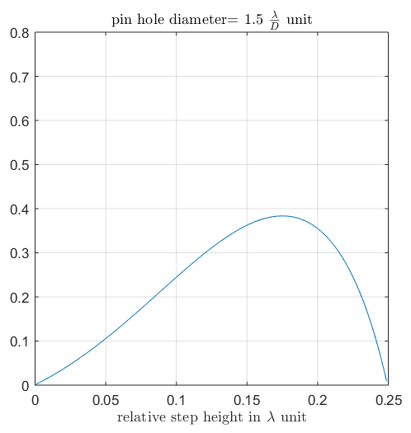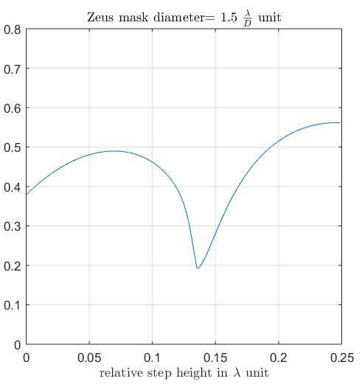
Figure 1: left the sensitivity of the pin hole with respect to the relative piston step between the segment, right the same for the phase contrast sensor
IFigure 1 shows the Fisher information as a function of the piston step, again with a pinhole or mask diameter of $\lambda/4$. This is not a arbitrary choice: in Surdej et al 2011, it has been demonstrated that the optimal diameter size of the phase mask is approximately 1.5 times the diameter of PSF, in this case the diameter of the Airy disk.
The mayor difference between the two sensors is that the phase contrast sensor is sensitive, although with significant variations, for all piston steps, whereas the sensitivity of the pinhole sensor goes to 0 for $\lambda \rightarrow 0$ and
$\lambda \rightarrow \lambda/4$. Surprisingly, for piston steps of $\lambda \approx 0.15 the pinhole sensor is more slightly sensitive than the phase contrast sensor.
The pinhole sensor could therefore be used for the measurements with modulations of the piston step, but not for measurements of small piston step under low level conditions.

This difference can be most easily interpreted when looking directly at the signals. Fig.? shows the difference between the signals for $\theta=??\lambda$ and $\theta=0$ for both sensors. In the case of the phase contrast sensor the step in the signal at $x=0$ is clearly seen. in the case of the pinhole the symmetric dip at $x=0$v is hardly visible.that when the piston step goes to zero the variation in the signal start to be extremely difficult to see with the pin hole. While for the phase contrast sensor as soon as there is the tiniest phase step the very characteristic signal appear.
In ideal condition, the phase contrast sensor would be more appropriate to deal with really small phase step. The pin hole sensor would also be so provided a x time longer exposure time.
However, with a pinhole or mask diameter of the size of the Airy disk, the signal is spread over the whole aperture. A localization or narrow signal is only achieved with much larger diameters. Fig. xx2 shows the Fisher informations as functions of the piston step for diameters of 60 times the Airy disk diameter. The dependence on the piston step is very similar to to the dependence in the case of small mask diameters.
Fig.xx2

Seeing limited case

Experimental result

Optimal sampling for phasing with phase mask
All the previous result were obtained with simulations using samplings that were at least 100 times better than realistic samplings.
The sampling has already been defined by Yaistkova et al 2005 as the width for which the signal drops under 10% of its maximum. Without the atmosphere the width of the signal is
,
wher the wavelength in micrometer and the angular diameter of the phase mask in arc second. . With a working wavelength of 0.65 and a pin hole diameter of 1”, the signal width is approximately 165 mm. For a segment size of 1420 mm edge to edge ithe signal width is approximate 1/10 of a segment.
The sampling will then be defined as the number of point across the signal width .
Fig.xx3 shows the dependence of the Fisher information on the sampling for both sensors. The pinhole sensor is much less sensitive to an undersampling. The mayor reason for this is the fact that its signal is symmetric.
Lets consider the most stringent ELT: the 39 meter build by ESO. Along one line there are 30 segment , the central obstruction is composed of 9 segment. All the 39 segment has to fit inside the camera, while providing sufficient sampling for the signal. Yaistskova et al 2010 recommend using 4 point across the signal width. This means the detector will have to be at least a 1600*1600 pixels detectors. I term of the Cramer Rao bound this means that the lowest possible error of the sensor change from to . This loss can easily be compensated by capturing twice the number of photon.
For the pin hole sensor, using the same sampling, this represent a loss of .

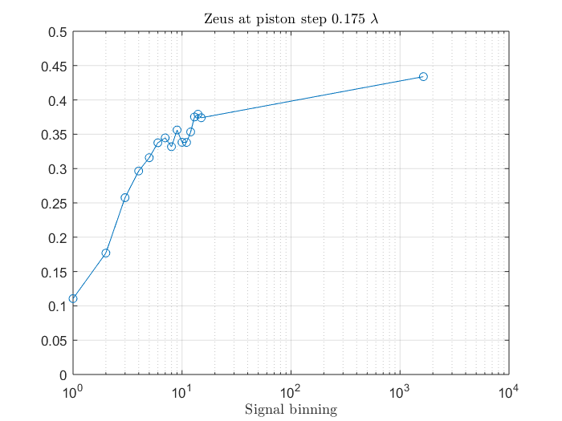
For this, in the context of the ZEUS sensor Surdej et al 2011 has defined There has already been estimate for the zeus sensor in yaistkova et al 2010.
